**LAB ASSIGNMENT 5**

NAME: TELANGE KHANDESHWAR GOVIND

ROLL NO: 22IT3058

T1.

<!DOCTYPE html>

<html lang="en">

<head>

<meta charset="UTF-8">

<meta name="viewport" content="width=device-width, initial-scale=1.0">

<title>T1</title>

<style>

body {

display: flex;

align-items: center;

justify-content: center;

height: 100vh;

margin: 0;

}

h2 {

transition: transform 0.5s ease-in-out;

}

.spin {

transform: rotate(360deg);

}

</style>

</head>

<body>

<h2 id="word">Hello! </h2>

<input type="text" id="inputBox" placeholder="Enter a word">

<button onclick="changeWord()">Change and Spin</button>

<script>

function changeWord() {

const inputBox = document.getElementById('inputBox');

const word = inputBox.value;

const heading = document.getElementById('word');

heading.innerText = word;

heading.classList.add('spin');

setTimeout(() => {

heading.classList.remove('spin');

}, 500);

}

</script>

</body>

</html>

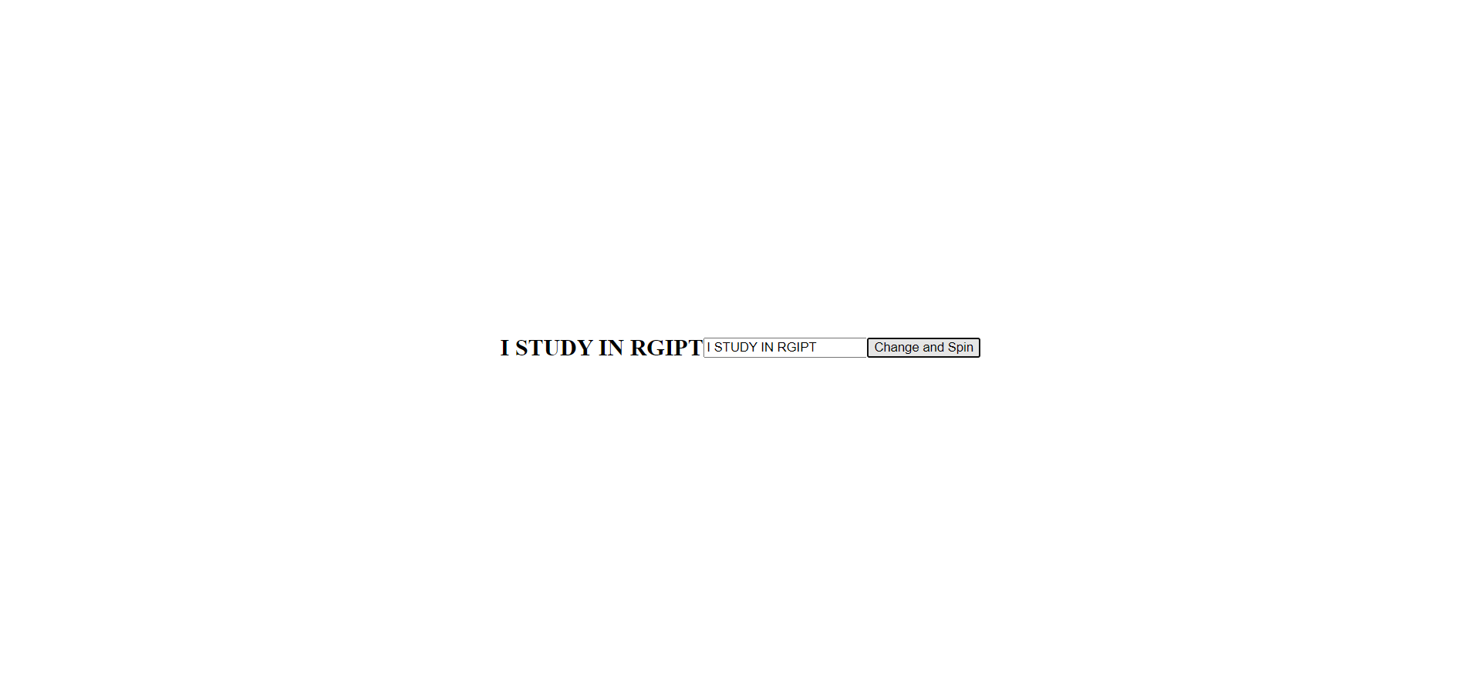

T2.

<!DOCTYPE html>

<html lang="en">

<head>

<meta charset="UTF-8">

<meta name="viewport" content="width=device-width, initial-scale=1.0">

<title>T2</title>

<style>

#count, #sentence {

font-size: 16px;

transition: font-size 0.2s ease-in-out;

}

</style>

</head>

<body>

<p id="count">0</p>

<p id="sentence">You have clicked the button 0 times.</p>

<button onclick="incrementCount()">Increment the count</button>

<script>

var count = 0;

var countParagraph = document.getElementById("count");

var sentenceParagraph = document.getElementById("sentence");

function incrementCount() {

count++;

countParagraph.textContent = count;

countParagraph.style.fontSize = count + "px"; // Update font size based on count

sentenceParagraph.textContent = "You clicked the button " + count + " time" + (count === 1 ? "" : "s") + ".";

}

</script>

</body>

</html>

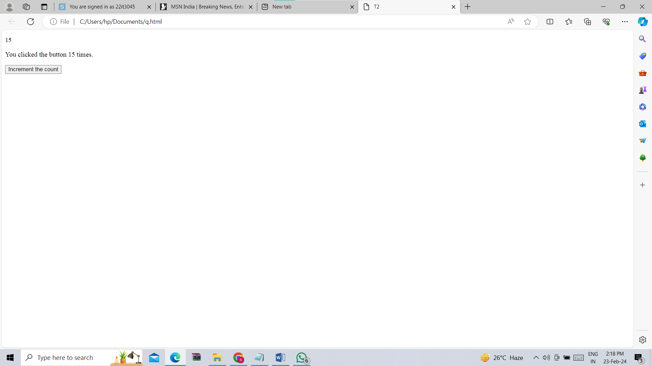

T3.

<!DOCTYPE html>

<html lang="en">

<head>

<meta charset="UTF-8">

<meta name="viewport" content="width=device-width, initial-scale=1.0">

<title>T3</title>

</head>

<body>

<button onclick="addToList()">Add Number to the List</button>

<ul id="numberList"></ul>

<script>

let count = 1;

function addToList() {

const numberList = document.getElementById('numberList');

const newItem = document.createElement('li');

newItem.innerText = count++;

numberList.appendChild(newItem);

}

</script>

</body>

</html>

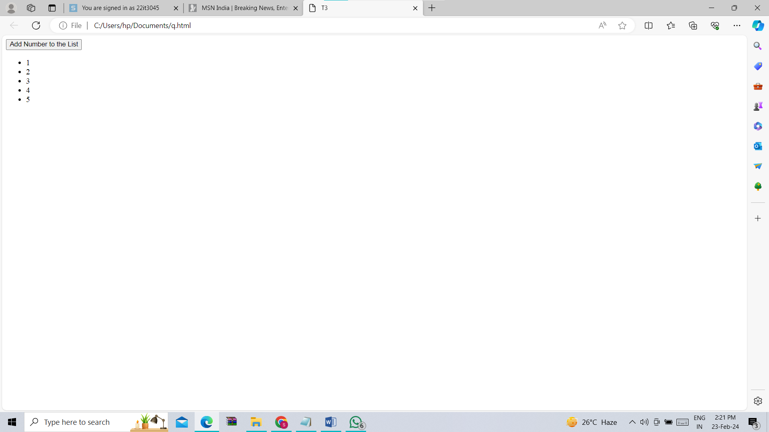

T4.

<!DOCTYPE html>

<html lang="en">

<head>

<meta charset="UTF-8">

<meta name="viewport" content="width=device-width, initial-scale=1.0">

<title>T4</title>

</head>

<body>

<table id="myTable" border="1">

<tr>

<td>1</td>

</tr>

<tr>

<td>1</td>

</tr>

</table>

<button onclick="addRow()">Add Row</button>

<script>

function addRow() {

var table = document.getElementById("myTable");

var rows = table.getElementsByTagName("tr");

var rowCount = rows.length;

var lastRow = rows[rowCount - 1];

var lastValue = parseInt(lastRow.innerText);

var previousRow = rows[rowCount - 2];

var previousValue = parseInt(previousRow.innerText);

var sum = lastValue + previousValue;

var newRow = table.insertRow(rowCount);

var cell = newRow.insertCell(0);

cell.innerText = sum;

}

</script>

</body>

</html>

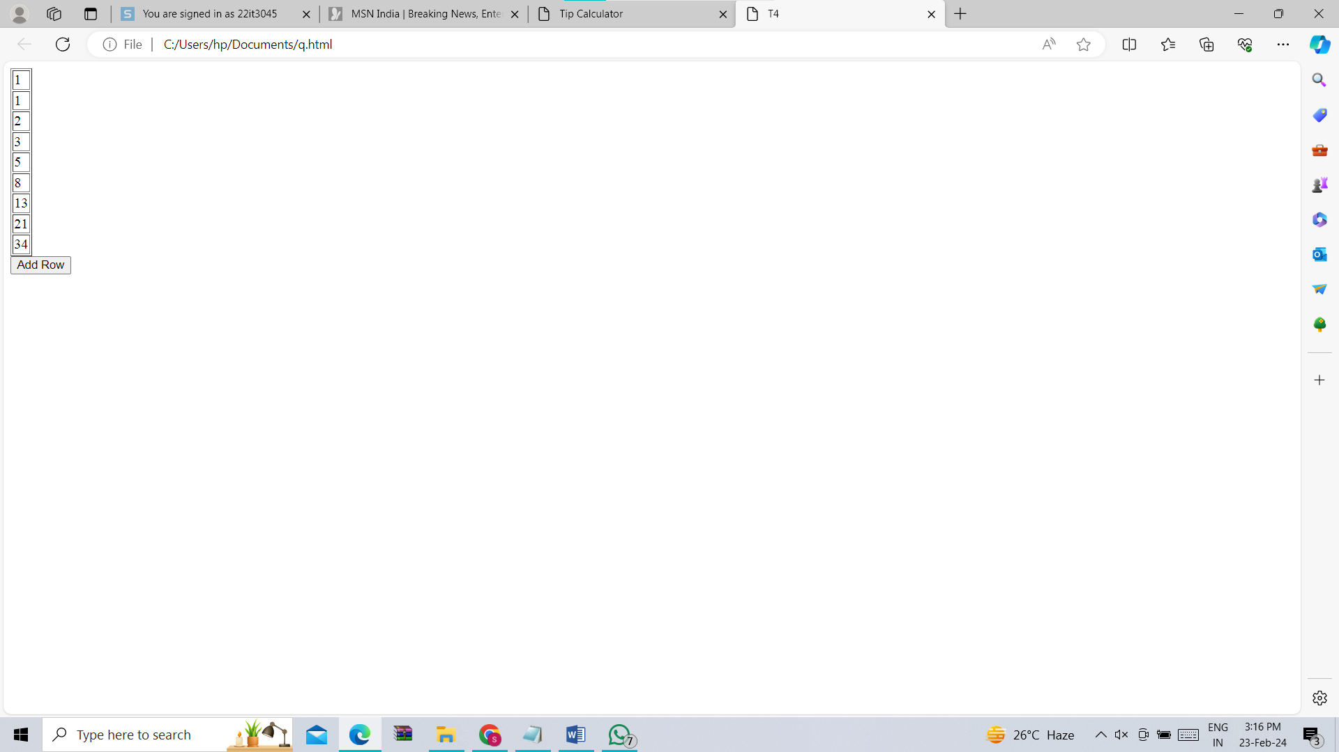

T5.

<!DOCTYPE html>

<html lang="en">

<head>

<meta charset="UTF-8">

<meta name="viewport" content="width=device-width, initial-scale=1.0">

<title>T5</title>

</head>

<body>

<label for="input1">Enter the first number:</label>

<input type="text" id="input1">

<label for="input2">Enter the second number:</label>

<input type="text" id="input2">

<br>

<button onclick="performOperation('+')">+</button>

<button onclick="performOperation('-')">-</button>

<button onclick="performOperation('*')">*</button>

<button onclick="performOperation('/')">/</button>

<br>

<div id="result">Result: </div>

<script>

function performOperation(operator) {

var input1 = Number.parseInt(document.getElementById("input1").value);

var input2 = Number.parseInt(document.getElementById("input2").value);

var result;

switch (operator) {

case '+':

result = input1 + input2;

break;

case '-':

result = input1 - input2;

break;

case '*':

result = input1 * input2;

break;

case '/':

result = input1 / input2;

break;

default:

result = "Invalid operator";

}

document.getElementById("result").innerText = "Result: " + result;

}

</script>

</body>

</html>

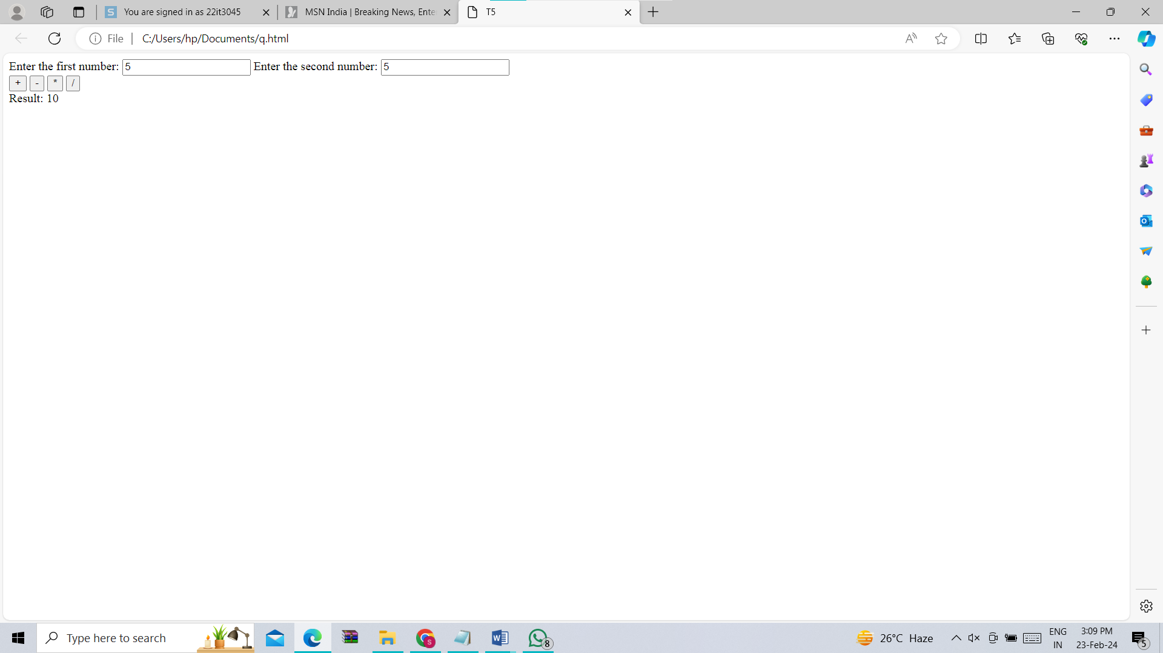

T6.

<!DOCTYPE html>

<html lang="en">

<head>

<meta charset="UTF-8">

<meta name="viewport" content="width=device-width, initial-scale=1.0">

<title>T6</title>

<style>

#container {

text-align: center;

margin-top: 50px;

}

#heading {

font-size: 24px;

}

ul {

padding-left: 0;

}

li {

margin-left: 0;

}

</style>

</head>

<body>

<button onclick="makePage();">Click Here</button>

<script>

function makePage() {

document.body.innerHTML = "";

var container = document.createElement("div");

container.setAttribute("id", "container");

document.body.appendChild(container);

var heading = document.createElement("h1");

heading.setAttribute("id", "heading");

heading.textContent = "Hi, I am H1 ";

container.appendChild(heading);

var paragraph = document.createElement("p");

paragraph.textContent = "This is a paragraph followed by a list.";

container.appendChild(paragraph);

var list = document.createElement("ul");

var listItem1 = document.createElement("li");

listItem1.textContent = "I. This is first";

list.appendChild(listItem1);

var listItem2 = document.createElement("li");

listItem2.textContent = "II. This is second";

list.appendChild(listItem2);

container.appendChild(list);

}

</script>

</body>

</html>

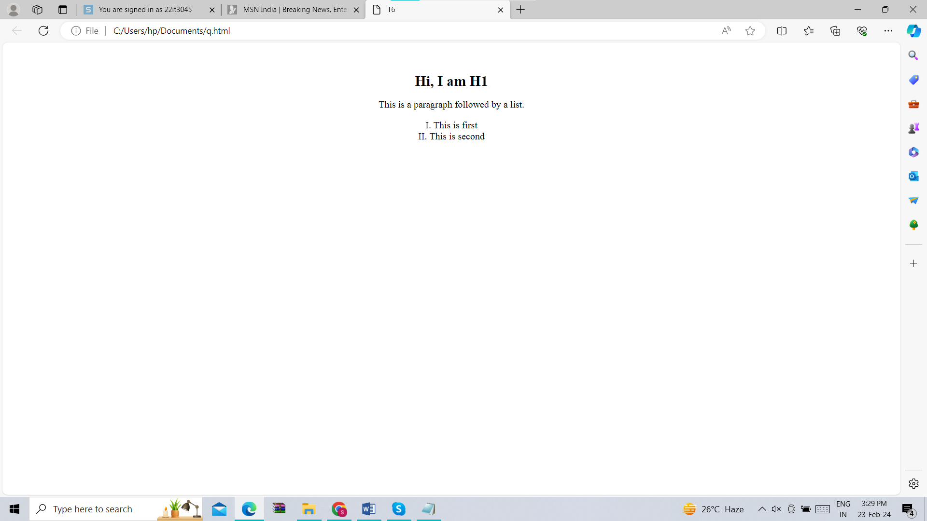

T7. <!DOCTYPE html>

<html lang="en">

<head>

<meta charset="UTF-8">

<meta name="viewport" content="width=device-width, initial-scale=1.0">

<title>Tip Calculator</title>

<style>

body {

font-family: Roboto, sans-serif;

display: flex;

flex-direction: column;

align-items: center;

justify-content: center;

height: 100vh;

margin: 0;

background-color: #f7f7f7;

}

label {

color: #333;

margin-bottom: 5px;

}

input[type="number"],

input[type="range"] {

width: 80%;

margin-bottom: 10px;

padding: 8px;

border: 1px solid #ccc;

border-radius: 5px;

}

input[type="range"] {

width: 100%;

}

button {

background-color: #4caf50;

color: #fff;

padding: 10px;

border: none;

border-radius: 5px;

cursor: pointer;

}

button:hover {

background-color: #45a049;

}

#totalTip {

font-size: 1.5em;

font-weight: bold;

margin-top: 20px;

color: #333;

}

</style>

</head>

<body>

<label for="billAmount">Enter Total Bill Amount:</label>

<input type="number" id="billAmount" placeholder="Enter total bill amount">

<label for="tipPercentage">Tip Percentage: <span id="tipPercentageValue">10%</span></label>

<input type="range" id="tipPercentage" min="0" max="30" step="1" value="10">

<label for="numberOfPeople">Number of People Visited: <span id="numberOfPeopleValue">1</span></label>

<input type="range" id="numberOfPeople" min="1" max="10" step="1" value="1">

<button onclick="calculateTip()">Calculate the Tip</button>

<div id="totalTip">Total Tip: $0.00</div>

<script>

function calculateTip() {

var billAmount = parseFloat(document.getElementById("billAmount").value) || 0;

var tipPercentage = parseInt(document.getElementById("tipPercentage").value);

var numberOfPeople = parseInt(document.getElementById("numberOfPeople").value) || 1;

var tipAmount = (billAmount * tipPercentage) / 100 / numberOfPeople;

document.getElementById("totalTip").innerText = "Total Tip: $" + tipAmount.toFixed(2);

}

document.getElementById("tipPercentage").addEventListener("input", function() {

document.getElementById("tipPercentageValue").innerText = this.value + "%";

});

document.getElementById("numberOfPeople").addEventListener("input", function() {

document.getElementById("numberOfPeopleValue").innerText = this.value;

});

</script>

</body>

</html>

